SALES DATASET ANALYSIS – ADVANCED EXCEL PROJECT

KISHORE VASUDEVAN

17/03/2025

DATA ANALYTICS & DATA SCIENCE

FEB 25’

**Data :**

The Superstores Sales Dataset contains **9,994** records and **21** columns, capturing details **about sales transactions**, including **order details**, **customer information**, **product categories**, and **financial metrics**. The dataset spans multiple years and regions, offering insights into business performance.

**Insights :**

Below are the some of key insights from the dataset

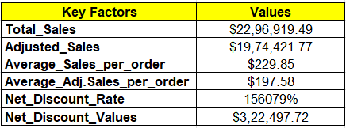

**Time Based Analysis :**

From the tables below, we can observe that all analyses—based on Date, Month, Quarter, Year, and Weekdays—indicate a higher occurrence in the second half of the period. For instance, when analyzing by date, the second half of the month (15th–31st) shows stronger numbers. Similarly, November has performed well in the monthly analysis, and this trend continues across other categories.

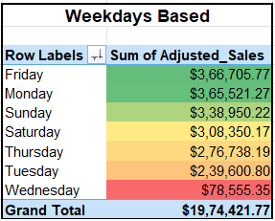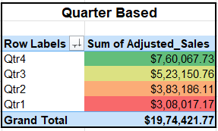

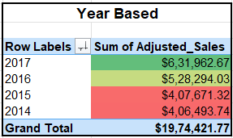

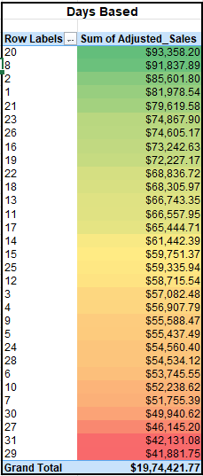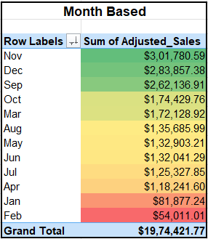

**Sales By Month :**

As mentioned earlier, the second half of the year has performed well. To better understand the sales trend, we can use a line chart to identify whether the trend is moving upward or downward. In this case, sales are on an upward trend, with the highest figures recorded in November with overall year data.

**Sales By Region :**

Among the regions, the West has performed the best, with a total sales value of $6,20,051.15 compared to others. On the other hand, the South has the lowest performance, with a sales value of $3,34,942.74. This indicates that the South region needs attention to improve sales.

**Sales By City :**

The dataset includes multiple cities, so we can focus on the top five cities with the highest sales performance. Among them, New York City leads with a sales value of $236,306.24, followed by Los Angeles at $154,050.96.

**Sales by Category :**

In the category-wise analysis, we can clearly identify which category has performed the best and which requires improvement. From the chart below, we observe that the Technology category recorded the highest sales at $713,493.38, while Furniture had the lowest sales at $618,286.29, indicating a potential area for improvement.

**Sales By Sales Channel :**

The Standard Class ship mode has the highest sales and profit margin, while Same-Day Delivery has the lowest. To attract more customers to Same-Day Delivery, consider offering additional benefits or discounts.

**Sales By Product Category with comparing the Quantity :**

Technology has the best performance, while Furniture is the lowest. However, in terms of quantity, Office Supplies have the highest numbers.

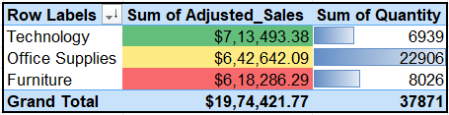

**Findings :**

* Based on sales performance, we should focus on the South region to increase sales and drive growth.
* We need to develop a marketing strategy to attract more customers not only by provide discounts and also by advertise on products to boost sales.
* Reducing discount percentages by slightly can help achieve a higher profit margin while maintaining sales.
* By analyzing the dataset, we observe an upward sales trend, with sales reaching **$6,31,962.67 (Adj. Sales) in 2017**, So we need to go with the same flow and increase in designs will help to achieve more in 2018 than the last year sales.
* The **Technology** category has consistently performed well each year, making it the ideal space to introduce **new products and strengthen market position** especially in **East & West**.